Multiple choice section

|  |  |  |  |  |  |  |  |  |  |  |  |
| --- | --- | --- | --- | --- | --- | --- | --- | --- | --- | --- | --- |
| Question | 1 | 2 | 3 | 4 | 5 | 6 | 7 | 8 | 9 | 10 | 11 |
| Answer | B | C | B | A | B | B | D | C | D | B | C |

Question 1 [7.2]

B

s + 12 = 35

Question 2 [7.3]

C

x ÷ 3 is the same as: 

Question 3 [7.2]

B

P = 2l + 2w

2x + 44 = 74

Question 4 [7.2]

A

Let n represent the number.

2 × n + 7 = 21

2n + 7 = 21

Question 5 [7.4]

B



4(x – 2) = 36

x – 2 = 9

x = 11

Question 6 [7.2]

B

Let n represent the number.

48 – n = 36

48 = 36 + n

n = 12

Question 7 [7.3]

D

Subtract 11 from both sides of the equation.

Question 8 [7.4]

C

7x – 3 = 18

7x – 3 + 3 = 18 + 3

7x = 21

7x ÷ 7 = 21 ÷ 7

x =3

Question 9 [7.4]

D











Question 10 [7.2]

B

t + 15 = 45

Question 11 [7.2]

C



($45.50 = 4550 cents and $14.45 = 1445 cents)

Multiple-choice total marks: 11

Short answer section

Question 12 2 marks [7.3]

(a) When backtracking, you undo an operation by using the inverse operation.

(b) To solve an equation is to find the value of the unknown.

Question 13 2 marks [7.3]

Backtracking is a method of solving equations where a flowchart to assist you in applying the inverse operations to an equation to solve for an unknown.

Question 14 3 marks [7.1]

|  |  |  |
| --- | --- | --- |
| (a)  LHS: 6 + 8 + 6 = 20 20 ÷ 2 = 10 RHS: 18 + 4 = 22 22 ÷ 2 = 11 LHS ≠ RHS false | (b) 28 – 6 × 2 = 4 + 18 – 6 LHS:6 × 2 = 12 28 – 12 = 16 RHS:4 + 18 = 22 22 – 6 = 16 LHS = RHS true | (c) 5 × 3 =  LHS: 5 × 3 = 15 RHS:45 ÷ 3 = 15 LHS = RHS true |

Question 15 1 mark [7.1]

T = 119 + 23 = 142 cm

Question 16 3 marks [7.2]

(a) y plus two is equal to eight

(b) a divided by five is equal to two

(c) six multiplied by x is equal to thirty-six

Question 17 2 marks [7.2]

|  |  |
| --- | --- |
| (a) Substitute b = 3 into b + 7:  3 + 7 = 10 Yes | (b) Substitute x = 12 into :    No |

Question 18 2 marks [7.3]

(a) × 7, + 1 (b) ÷ 6, – 9

Question 19 2 marks [7.3]

(a) 3x + 4 = 22 (b) x = 6

Question 20 2 marks [7.3]

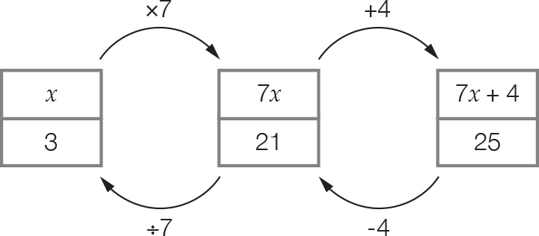

x = 3

Question 21 2 marks [7.3]

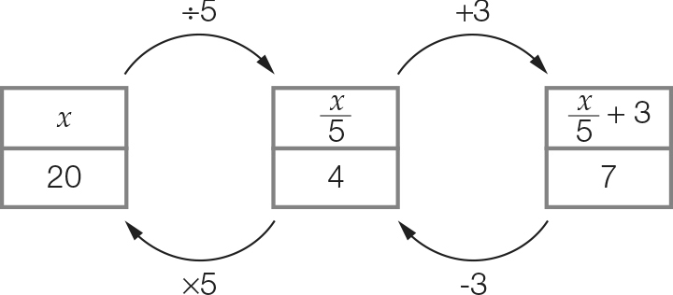

x = 20

Question 22 4 marks [7.4]

|  |  |
| --- | --- |
| (a) | (b) |

Question 23 2 marks [7.4]

Let n represent the number.

2n + 8 = 26

2n = 18

n = 9

Question 24 6 marks [7.4]

(a) x + 9 = 12 (+ 4)  
x + 9 + 4 = 12 + 4  
x + 13 = 16  
Check the solutions to both equations.  
Old x = 3; New x = 3

(b) x – 11 = 14 (+ 2)  
x – 11 + 2 = 14 + 2  
x – 9 = 16  
Check the solutions to both equations.  
Old x = 25; New = 25

(c) x – 7 = 3 (– 8)  
x – 7 – 8 = 3 – 8  
x – 15 = -5  
Check the solutions to both equations.  
Old x = 10; New x = 10

Question 25 6 marks [7.4]

|  |  |  |
| --- | --- | --- |
| (a) 4x + 8 = 40 4x + 8 – 8 = 40 – 8 4x = 32 4x ÷ 4 = 32 ÷ 4 x = 8 | (b) | (c) 7(x – 3) = 28 7(x – 3) ÷ 7 = 28 ÷ 7 x – 3 = 4 x – 3 + 3 = 4 + 3 x = 7 |

Question 26 3 marks [7.5]

5 school days with 2 trips per day, equals 10 trips.

Let d represent the distance of the bus depot to school.

10 × d + (125 × 2) = 648

10d + 250 = 648

10d = 398

d = 39.8 km

Question 27 2 marks [7.5]

c = 9. 60 – 2.70 = $6.90

Question 28 3 marks [7.5]

4x + x = 85

5x = 85

5x ÷ 5 = 85 ÷ 5

x = 17

17 × 4 = $68

Michael has $17.

Benny has $68.

Question 29 4 marks [7.5]

(a) P = 2l + 2w  
72 = 2(3w) + 2(w)  
72 = 6w + 2w  
72 = 8w  
w = 9 cm  
l = 9 × 3 = 27 cm

(b) A = l × w  
= 9 × 27  
= 243 cm2

Question 30 3 marks [7.5]

(a) 410 – 56 = 3j

(b) 410 – 56 = 3j  
354 = 3j  
j = 118  
Each shirt cost $118.

Short answer total: 54

Extended answer section

Question 31 3 marks [7.5]

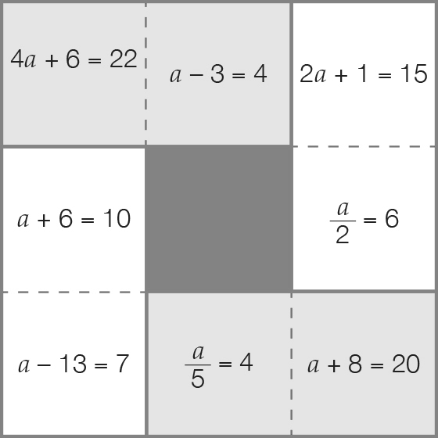

Question 32 5 marks [7.5]

Let A = number of cookies made by machine A.

Let B = number of cookies made by machine B.

Let C = number of cookies made by machine C.

A = 4B

C = A + 400

C = 4B + 400

A + B + C = 20 200

|  |  |  |
| --- | --- | --- |
| 4B + B + 4B + 400 = 20 200  9B + 400 = 20 200  9B = 19 800  B = 2200 | A = 4B  A = 4 × 2200  A = 8800 | C = A + 400  C = 8800 + 400  C = 9200 |

Check by using A + B + C = 20 200

8800 + 2200 + 9200 = 20 200

Machine A makes 8800, machine B makes 2200 and machine C makes 9200 cookies.

Question 33 6 marks [7.5]

(a)

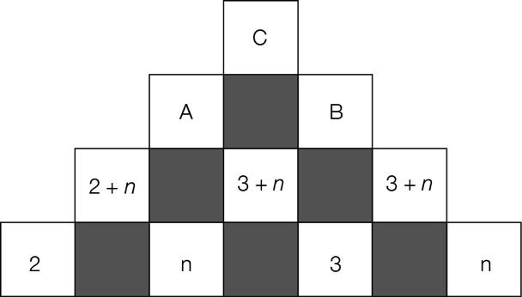

A: 5+ 2n

B: 6 + 2n

C: 5 + 2n + 6 + 2n = 11 + 4n

(b) 11 + 4n = 15

(c) 11+ 4n = 15  
4n = 4  
n =1  
Substituting n = 1 into the expression 5 + 2n to find A: 5 + 2(1) = 7  
Substituting n = 1 into the expression 6 + 2n to find B: 6 + 2(1)= 8  
To check C = A + B; 15 = 7 + 8 is a true number sentence.

Extended answer total: 14

TOTAL test marks: 79